**CREATING IBM CLOUD SERVICE**

|  |  |
| --- | --- |
| **Date** | 03 NOVEMBER 2022 |
| **Team ID** | PNT2022TMID00354 |
| **Project Name** | SMART WASTE MANAGEMENT FOR METROLPOLITAN CITIES |

# TEAM LEADER SANJAY KUMAR T

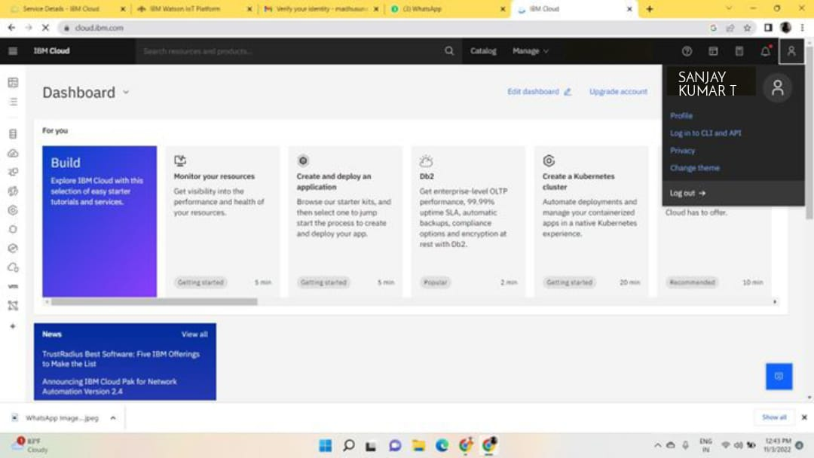

# TEAM MEMBER 1 VINO JOSELIN G

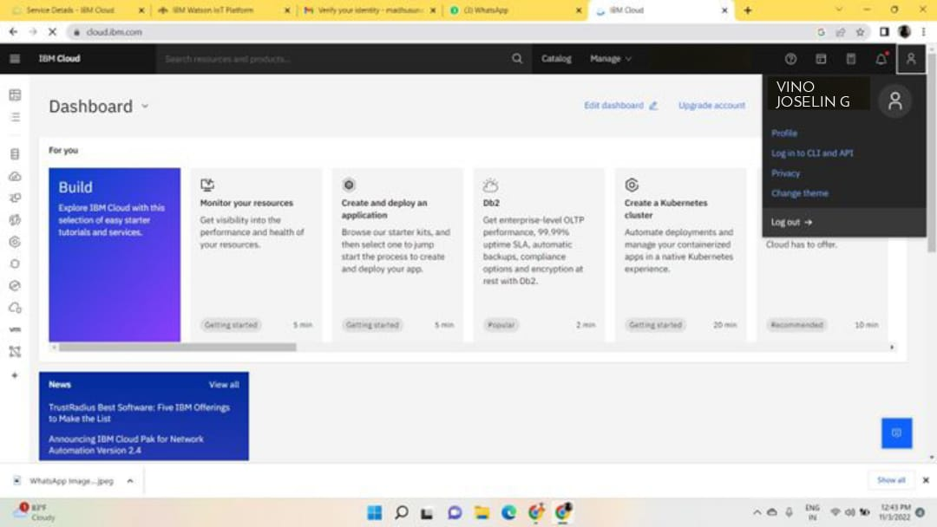

# TEAM MEMBER 2 NARESH KUMAR T

# TEAM MEMBER 3 THANGAPRAKASAM

An IBM Cloud Service created Successfully .